PIZZA SALES REPORT

**KPI:**

sum of Total Revenu:

select SUM(total_price) as Total_revenue from pizza_sales;

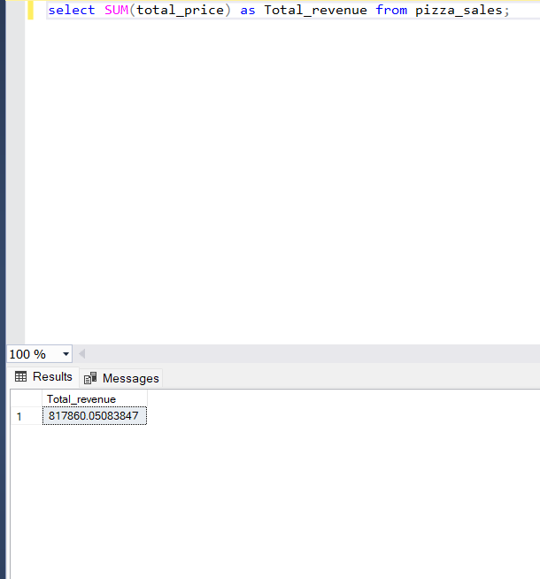

Average Order Value:

select (sum(total_price)/COUNT(Distinct order_id)) as Avrage_order_value from pizza_sales;

total pizza sales

select sum(quantity) as number_of_pizza_soldes from pizza_sales;

total order place

select count(DISTINCT order_id) as Total_order_Place from pizza_sales;

avg number of pizzas sales per order

cast(cast(sum(quantity) as decimal(10,2))/cast(count(DISTINCT order_id) as decimal(10,2)) as decimal(10,2)) as Avg_number_of_pizza_per_order from pizza_sales;

chart requirement

select total order by each day per week

select DATENAME(DW,order_date) as order_day,

count(Distinct order_id) as total_order

from pizza_sales

group by DATENAME(DW,order_date);

select a query for daily trend by hourly

select DATENAME(month,order_date) as month_name,

count(Distinct order_id) as total_order

from pizza_sales

group by DATENAME(month,order_date)

order by total_order desc;

percentage of sales by pizza category

select pizza_category,sum(total_price)*100/(select sum(total_price) from pizza_sales)

as total_sales

from pizza_sales

group by pizza_category;

jan month

select pizza_category,sum(total_price)as total_sales,sum(total_price)*100/(select sum(total_price) from pizza_sales where month(order_date)=1)

as pct

from pizza_sales

where month(order_date)=1

group by pizza_category;

percentage of sales by pizza size

select pizza_size,sum(total_price)as total_sales,sum(total_price)*100/(select sum(total_price) from pizza_sales)

as pct

from pizza_sales

group by pizza_size;

top 5 pizza sales by sales

select top 5 pizza_name,sum(total_price) as total_ravaneu from pizza_sales

group by pizza_name

order by total_ravaneu desc;

bottom 5 pizza by sales

select top 5 pizza_name,sum(total_price) as total_ravaneu from pizza_sales

group by pizza_name

order by total_ravaneu ;

top 5 pizza sales by quantity

select top 5 pizza_name,sum(quantity) as quantity from pizza_sales

group by pizza_name

order by total_ravaneu desc;

bottom 5 pizza by quantity

select top 5 pizza_name,sum(quantity) as quantity from pizza_sales

group by pizza_name

order by total_ravaneu ;